Installation and use instructions

# Set-up

This application is developed resorting .NET 6 WPF.

Hence it may require you to install the .NET Desktop Runtime 6.0.0 from the Microsoft™ website.

From the webpage, choose **Run Desktop Apps**

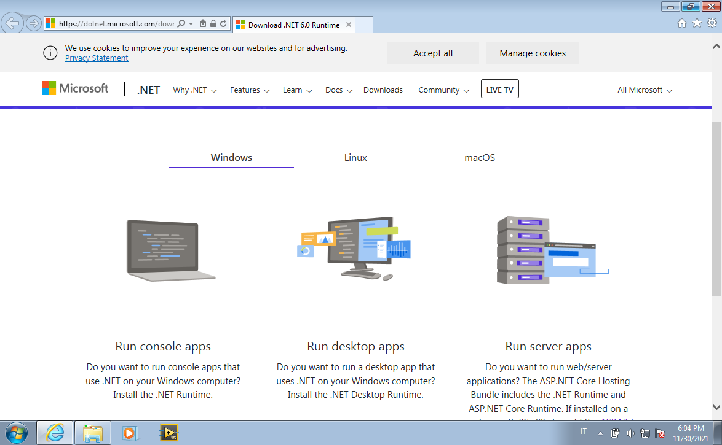

Then which version do you need to download, based on your computer (usually **Download x64**).

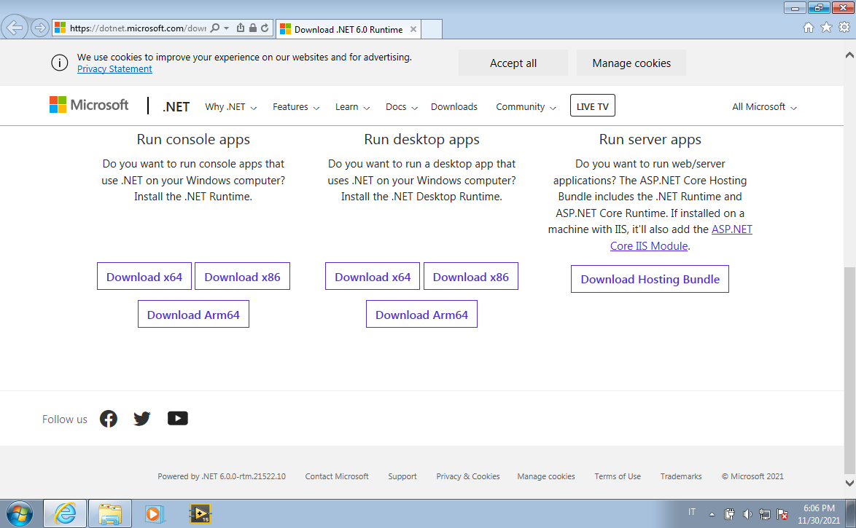

So install it:

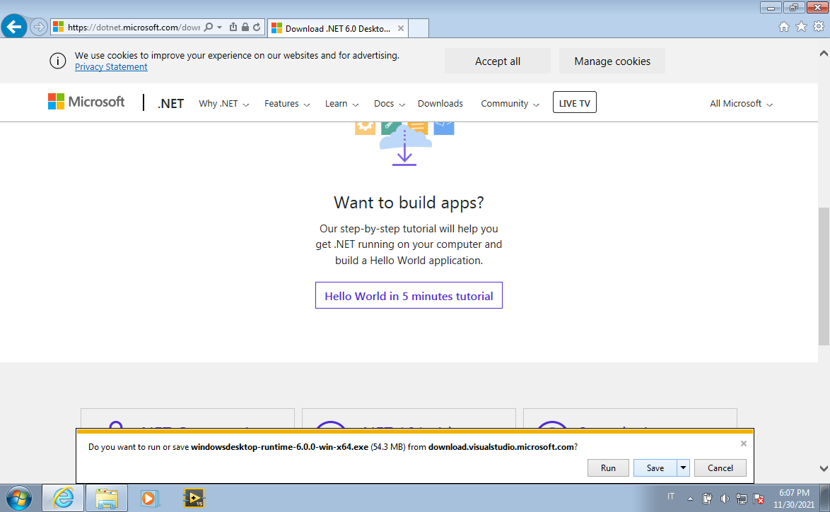

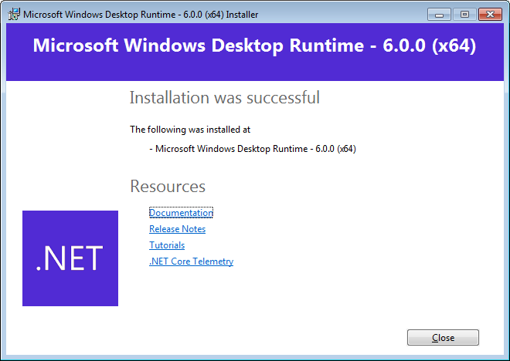

Then run the application.

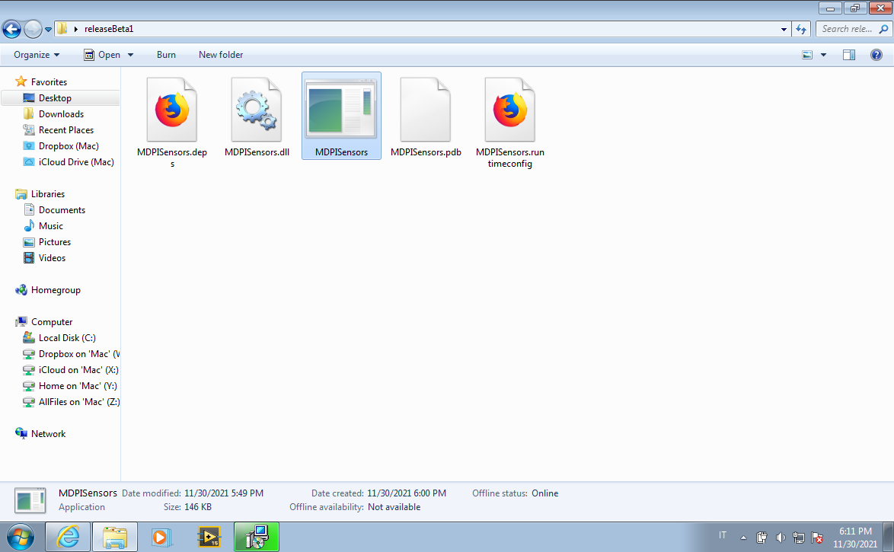

# use of the application

1. Launch the application.

2. Then, press the **Start** button.

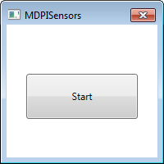

3. It will ask you when to save the log file to be provided alongside the video recording.

If it works properly, the windows show a blinking hourglass.

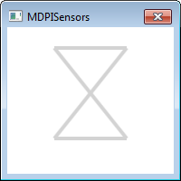

4. At the end of the lecture, close it by pressing the close button of the windows (the one with the x symbol).

The log file saved should have this form:

